Revolution With AI
Survey Research Report
Course: Applications of ICT Lab (AICTL)
Instructor: Ms. Ramsha Khalid
Group Members:
-Muhammad Ahmad Mustafa 2025-GA-39
-Faran Ahmed Sultan 2025-GA-15
-Muhammad Samil 2025-GA-01
-Adina Tanvir 2025-GA-47
-Maham Javed 2025-GA-49
Semester: 1st Fall 2025
Session: 2025-2029

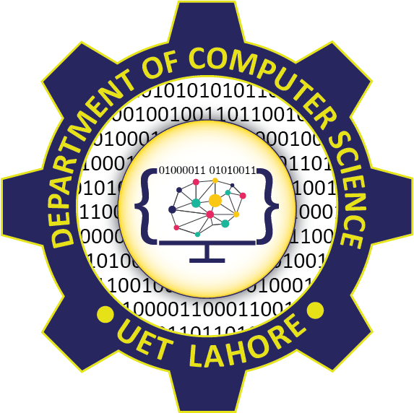

Table of Content

1.Introduction
2.Objective of report
3.Data Collection
4.Survey Summary & Insights
5.Visual Analysis & Charts
6.Findings & Interpretation
7.Conclusion
8.Recommendations

1. Introduction
Artificial Intelligence (AI) is rapidly transforming industries, education, and everyday life. AI Resolution refers to the clarity, accuracy, and detail level achieved by an Artificial Intelligence system when generating, recognizing, or processing data such as images, videos, or text. This revolution is not just about technology; it represents a shift toward a smarter, more connected, and efficient world, where human intelligence and artificial intelligence work together to solve complex problems and improve daily life. This survey was conducted to understand student awareness, opinions, and expectations regarding AI. The goal is to highlight how young individuals perceive AI’s role in the future and involve themselves in the AI revolution.

2.Objective of report
The main objective of this report is to analyze the impact of the Artificial Intelligence (AI) Revolution across key sectors such as education, business, transportation, cybersecurity and health. It aims to understand how AI is transforming these fields through automation, data analysis, and smart decision-making.
The report also seeks to evaluate public awareness and attitudes toward AI, highlight its benefits and challenges, and provide recommendations for promoting safe, ethical, and effective use of AI in everyday life. Ultimately, this report aims to provide a clear understanding of how Artificial Intelligence is transforming modern society and to encourage responsible adoption of AI for sustainable development. The overall goal is to promote awareness, guide innovation, and ensure that the AI Revolution benefits humanity in a safe and ethical manner.

3. Data Collection
A Google Form was used to collect data from students. The form included multiple-choice, rating, and open-ended questions. A total of 31 responses were recorded.

Total Responses | 31
Age Group | 29% Under 18  71% Above 18
Gender | 83.9% Male  12.9% Female  3.2% Prefer not to say

4. Survey Summary & Insights
Key highlights from the survey:
- Majority of students are familiar with AI.
- Most common AI tools used: ChatGPT, Google Gemini, and Microsoft Copilot.
- Students believe AI impacts Education, Business, and Entertainment sectors the most.
- Participants expect AI to create new opportunities while automating repetitive tasks.

5. Visual Analysis & Charts
Age Distribution:
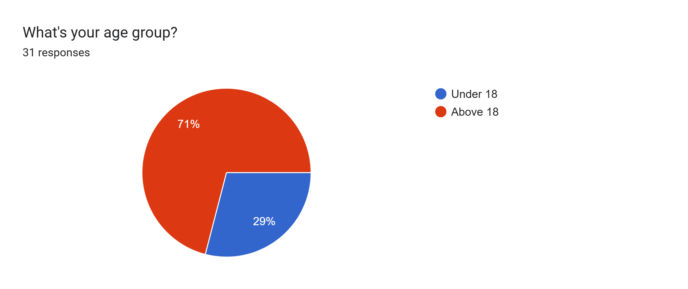

Gender Distribution:
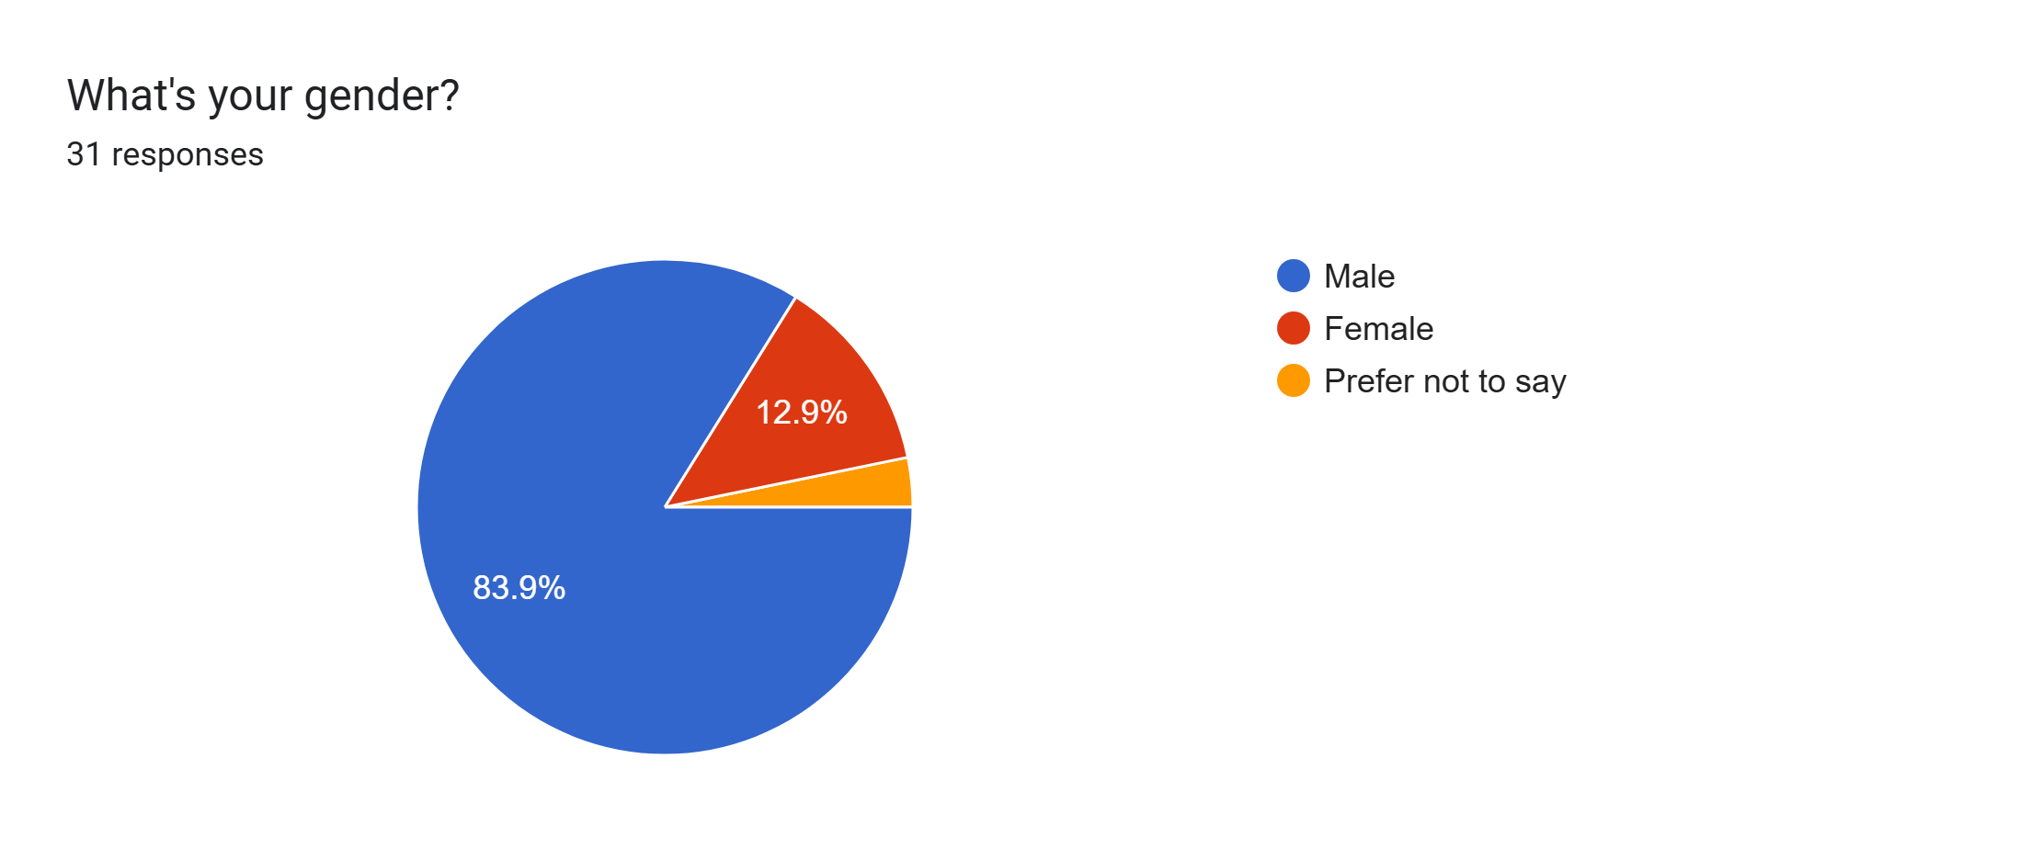

Impact of AI:
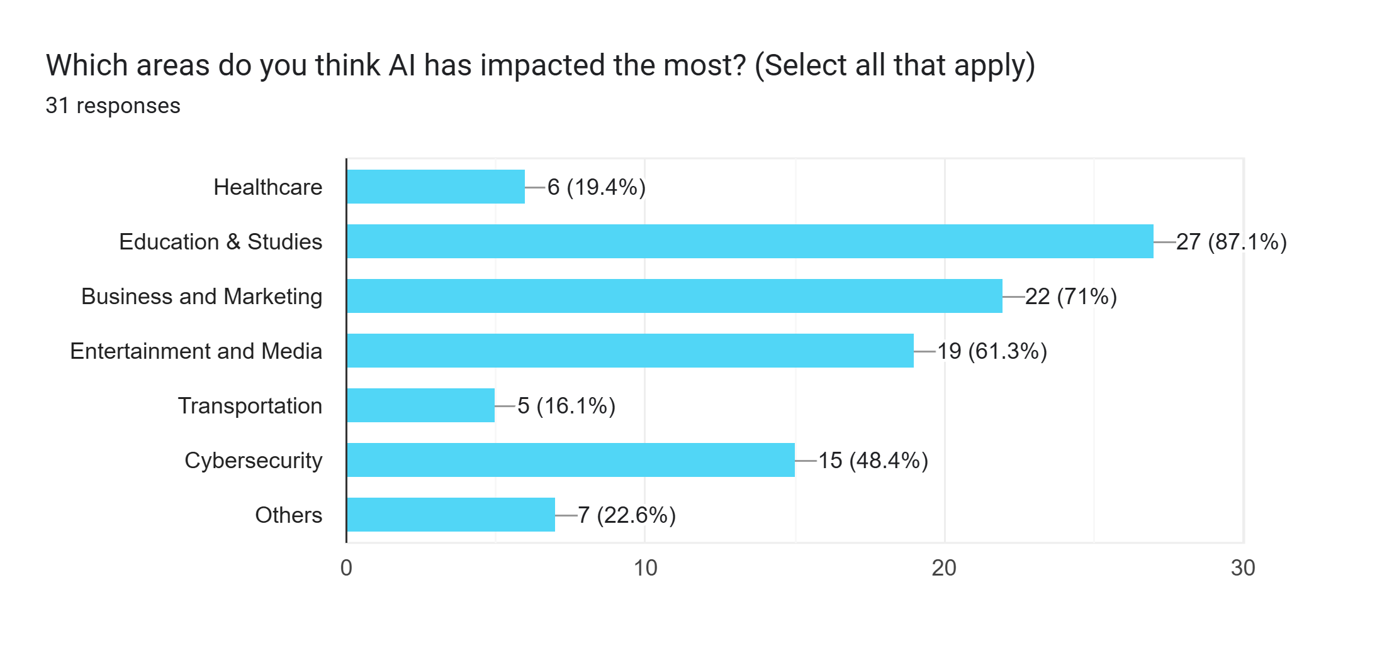

More important skills:
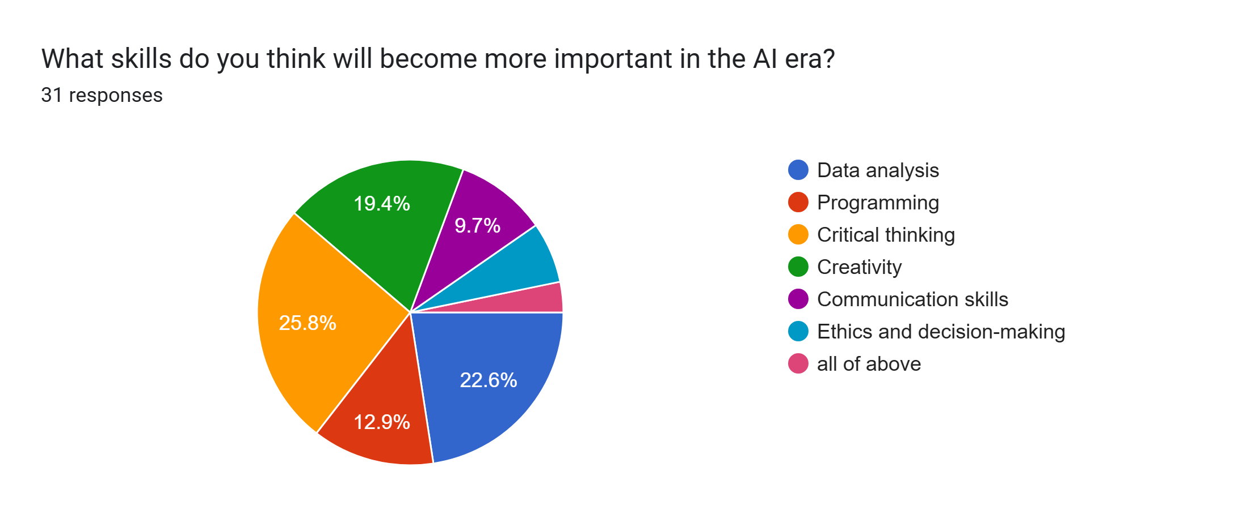
Note:
The survey results show that people recognize the growing importance of various skills in the Artificial Intelligence (AI) era. The highest-rated skills include critical thinking, data analysis, programming, and communication, which are essential for success in an AI-driven world. A balance of reasoning, data skills, and communication will prepare individuals to adapt and lead in a technology-driven future.

6. Findings & Interpretation
The survey reflects a positive perception toward AI among students. They see AI as a tool that enhances productivity and accelerates learning. However, participants also acknowledged concerns about job automation and ethical risks. Most participants rated education as the top area benefiting from AI.
- AI supports personalized learning, virtual classrooms, and automated grading.
- It helps improve teaching quality and accessibility for students.

7. Conclusion
AI awareness is strong among the surveyed group. Most students show willingness to learn AI-related skills to stay relevant in the future job market. The AI Revolution is shaping a smarter, more connected world by advancing education, business, health, media, cybersecurity and transportation for the future. The AI Revolution is shaping the future by making systems smarter, faster, and more efficient. Its influence in education, business, and transportation highlights how technology can create new opportunities and improve quality of life.

8. Recommendations
- Encourage AI literacy and ethical understanding.
- Practice responsible use of AI tools.
- Build skills in creativity, problem-solving, and critical thinking.
- Engage in technical learning like programming and data handling.
- Promote AI training and awareness programs for students and employees.
- Encourage collaboration between industries and educational institutions for AI-based innovation.
- Adopt ethical AI policies to ensure data privacy and fairness.
- Invest in infrastructure for AI-driven transportation systems
- Educate people about how AI and digital tools (like health apps or telemedicine platforms) work, so they can use them safely and effectively.
- Provide regular AI and cybersecurity training for doctors, pharmacists, and nurses to help them handle electronic health records safely.
________________________________________

